**MOTOR POSTION CONTROL WITH MATLAB USING RASPBERRY PI (PD CONTROL)**

**OBJECTIVE:**

* To develop a PD controller for a motor that can follow the position accurately.
* The input here is a sine wave, so the objective is for the motor to follow the sine wave position signal.
* Run the model in real time using wifi.

**CIRCUIT DIAGRAM:**

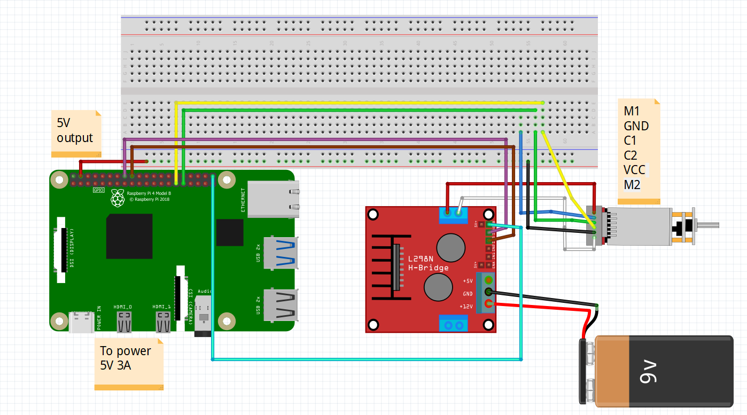

|  |  |
| --- | --- |
| MOTOR PINS | GPIO PINS |
| C1 (Encoder pulse A) | 6 |
| C2 (Encoder pulse B) | 5 |
| IN1 | 23 |
| IN2 | 24 |
| ENA (PWM pin) | 21 |

**SETUP:**

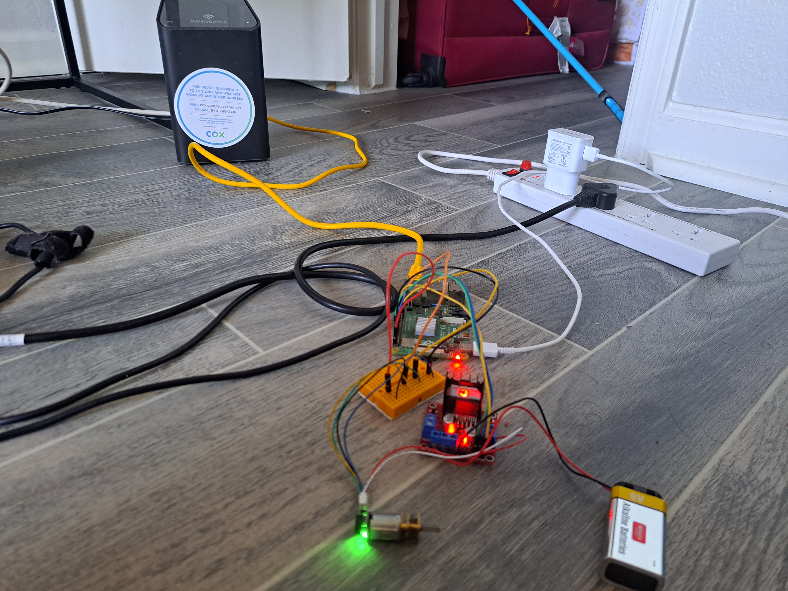

**SIMULINK MODEL:**

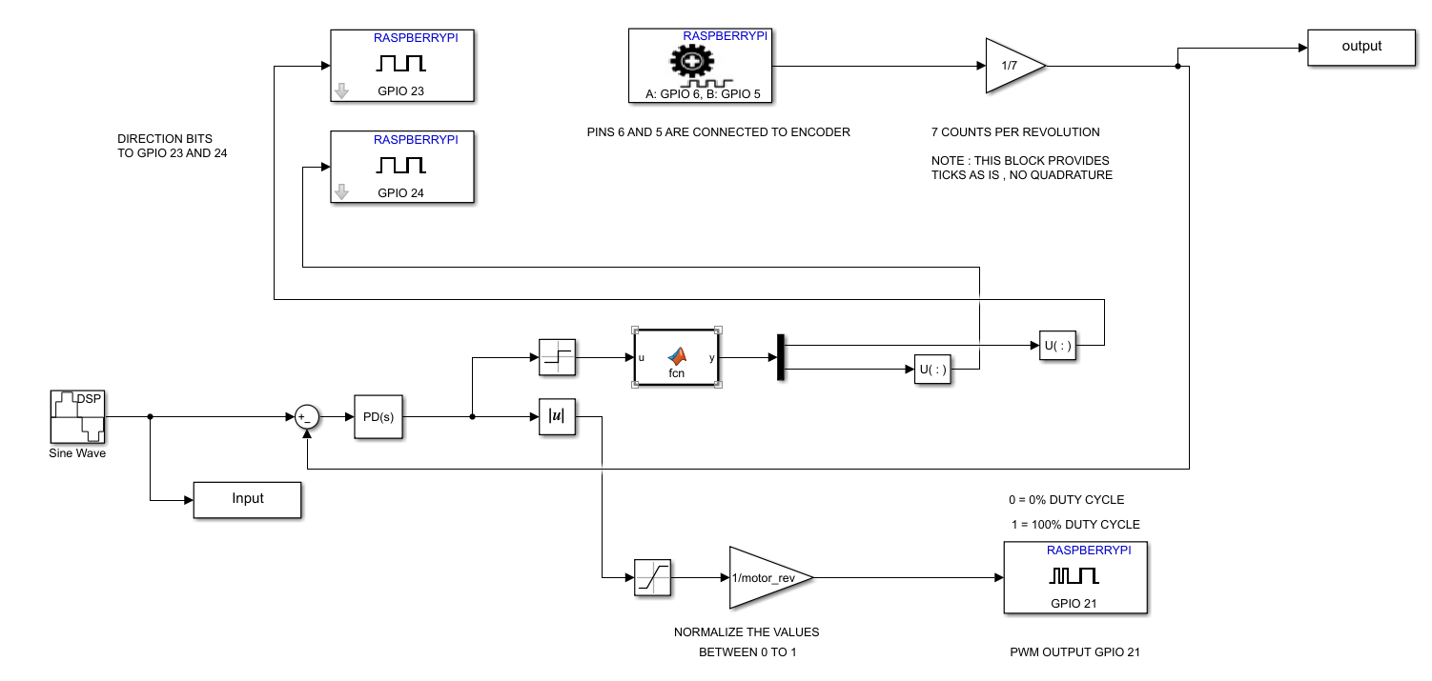

**DESCRIPTION:**

* The connections are given as shown in circuit diagram.
* The Raspberry pi is connected to my wifi router using an Ethernet cable.
* My Laptop is connected wirelessly to the same wifi router.
* The maltab code will run in realtime over the wifi to my raspberry pi.
* The data is obtained in real time and the graph is plotted.

**GRAPH:**

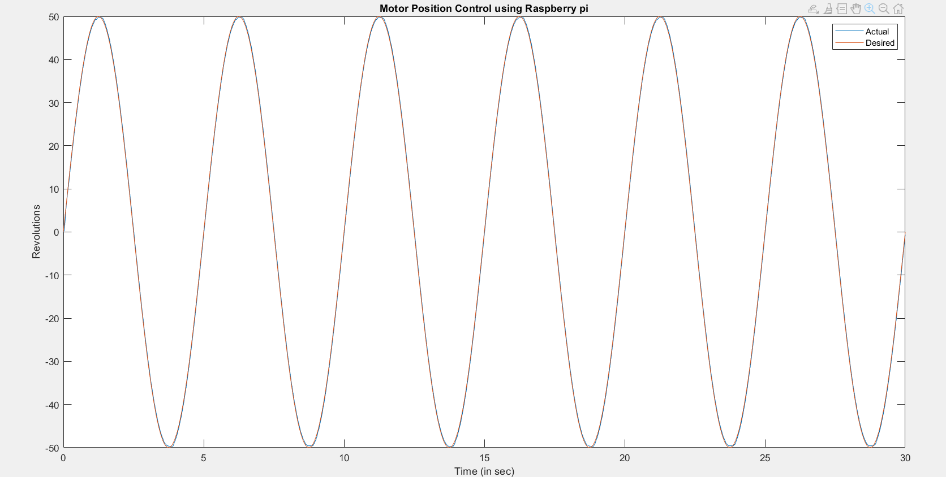

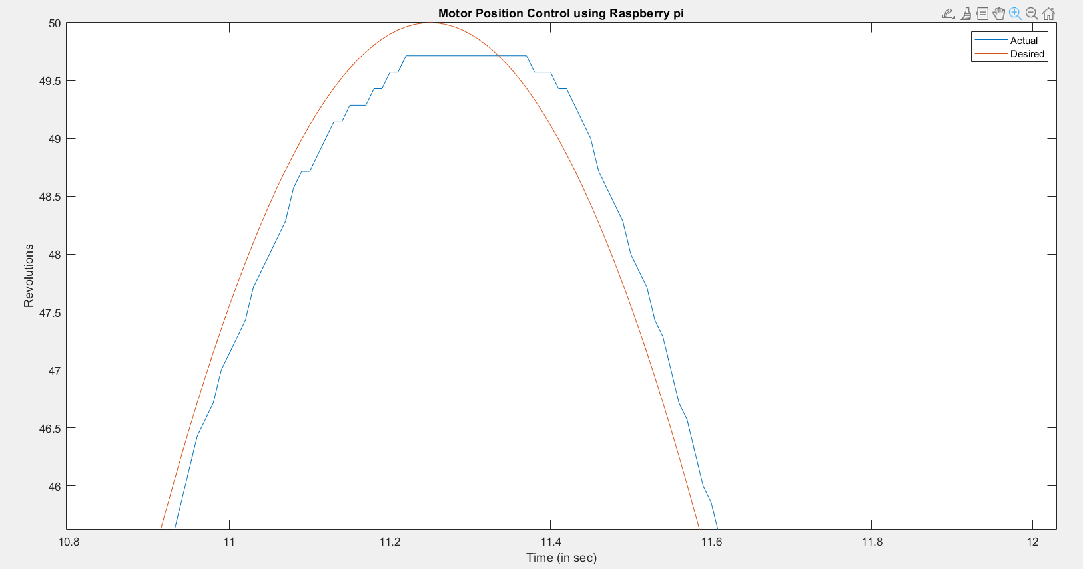

**Observations:**

* In the graph obtained, the motor was able to follow the position of the sine wave pretty accurately.
* Comparing boards that have less memory and computing power (such as Leonardo), using powerful boards (such as Raspberry pi) significantly improves the controlling capability.